St. Xavier’s College (Autonomous), Mumbai

Class – TYBSc (2021-22)

CIA 2 - R Assignment



**TOPIC:**

 **A peek into the History of OLYMPICS**

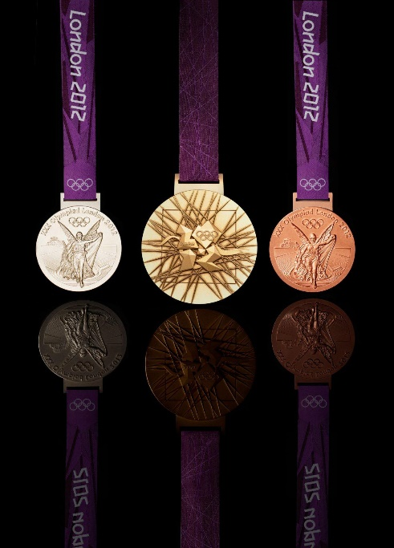

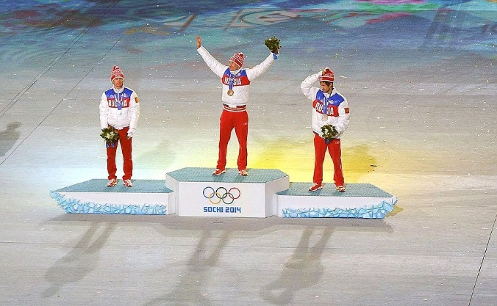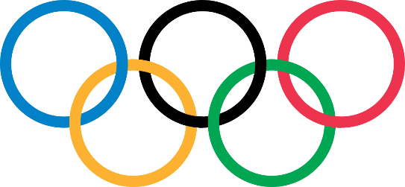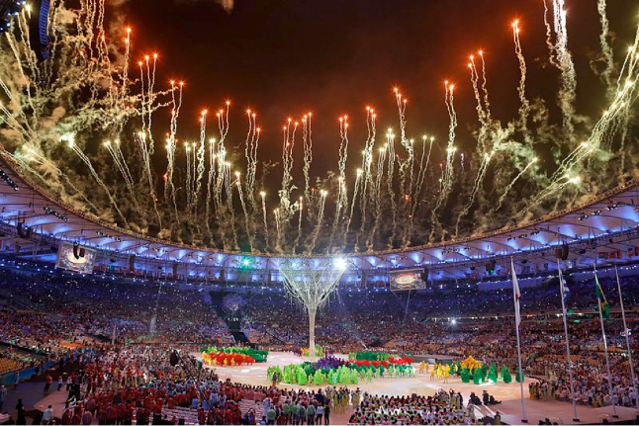

**Group Members**

1. Name: Devishree Panchal

Roll No.: 415

UID: 192240

Email Id: [dhpanchal01@gmail.com](mailto:dhpanchal01@gmail.com)

1. Name: Apurva Nandkishor Yemul

Roll No.: 429

UID: 192350

Email Id: [192350.apurvayemul@gmail.com](mailto:192350.apurvayemul@gmail.com)

**DATASET**

We have used two datasets related to Olympics.

* [summer data.csv](https://drive.google.com/file/d/1nyvDWVosflMvlls3zS2vs0AqMHw4lyb6/view?usp=sharing)
* [GDP data.csv](https://drive.google.com/file/d/1fa8CJ3Scf3_VYKN_lKjZT8HA6TlSk91g/view?usp=sharing)

After watching the recent 2020 Tokyo Olympics, we were very excited to know more about the Olympics held in the past years. Hence, we decided to peek into the History of Olympics.

The “summer data.csv” is the data set consisting the various events and the winning of each event. The data is majorly Categorical.

Hence, we used a numerical dataset, “GDP data.csv” which shows the country-wise GDP per capita and Total Population for the year 2012.

We acquired our secondary datasets from the following source:

[Olympic Sports and Medals, 1896-2014 | Kaggle](https://www.kaggle.com/the-guardian/olympic-games?select=summer.csv)

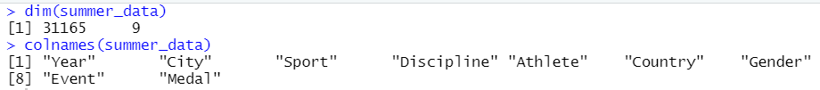Summer data has 31165 rows and 9 columns as shown below:

GDP data has 201 rows and 4 columns as shown below:

